Overview
From the View recent travel claims screen you can see the status and review the details of travel expense claims you have submitted. You are also able to edit or delete travel expense claims you have saved as a draft or initiate a new travel expense claim.

The View recent travel claims screen.
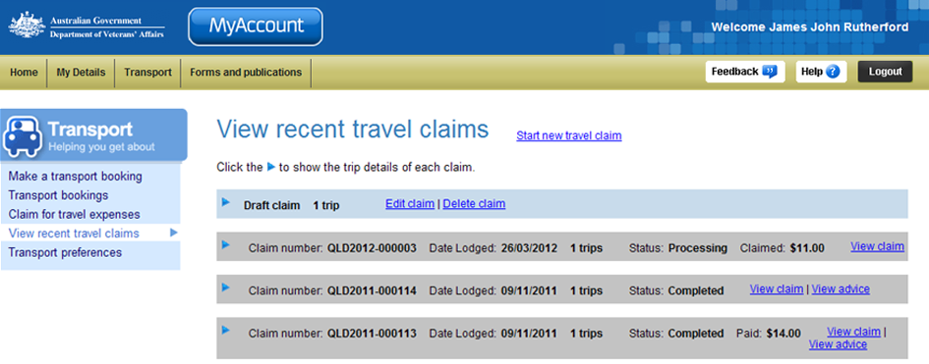
Transport menu.
Submitted claims.
Draft claim.
Start a new travel claim link.
Claims that have not been submitted are displayed as a ‘Draft claim’ and appear in a blue box. Claims that have been submitted are displayed with the status ‘Processing’ or ‘Completed’ and appear in a grey box.
Claims are listed in date order, with draft claims at the top of the list followed by submitted claims.

View claim details
For each claim, information is displayed in a summarised view. To view the details of a claim:
- To view details of individual trips on the claim, click on the icon (twistie).
The claim "status" and "amount" may not be displayed for all claims. Please note that your claim has been received and a written advice will be posted to you when processing of your claim has been completed.

The View recent travel claims screen – the most recent submitted claim is expanded.
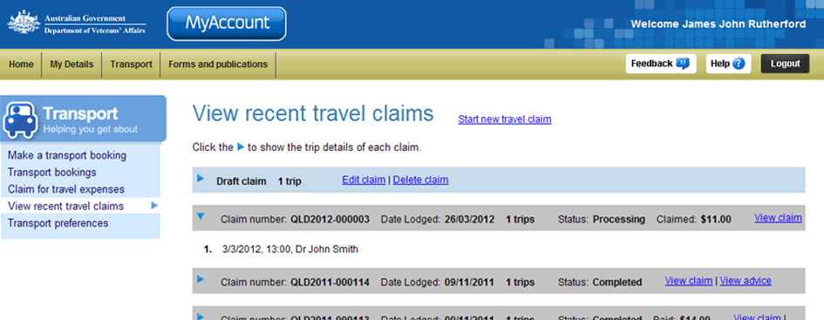
List of trips added to this claim.
- To view the full details of the claim, including the breakdown of amounts claimed for each trip, click on the View claim link to the right of the claim.

The View claim for travel expenses screen displays
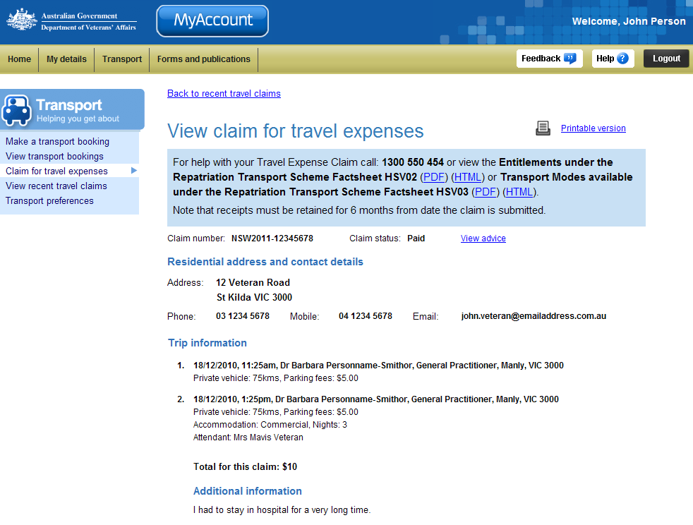
Help information and fact sheets
Claim status
Trips added to this claim
- To return to the View recent travel claims screen, click on the Back to recent travel claims link at the top of the screen.

The View recent travel claims screen displays.
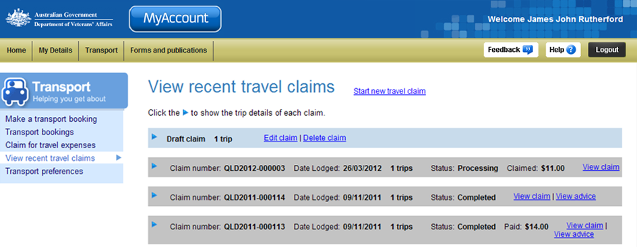

Completed claims
- To view a copy of the claim advice letter for claims with a status ‘Completed’, click on the View advice link to the right of the claim.

The View claim advice screen displays.
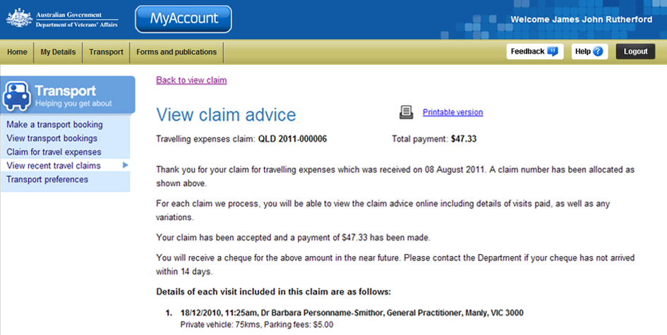
- To return to the View recent travel claims screen, click on the Back to view claim link at the top of the screen.
You have successfully viewed the claim details.

Edit a draft claim
To edit a draft claim:
- Click on the Edit claim link to the right of the draft claim.

The Edit claim for travel expenses screen displays.
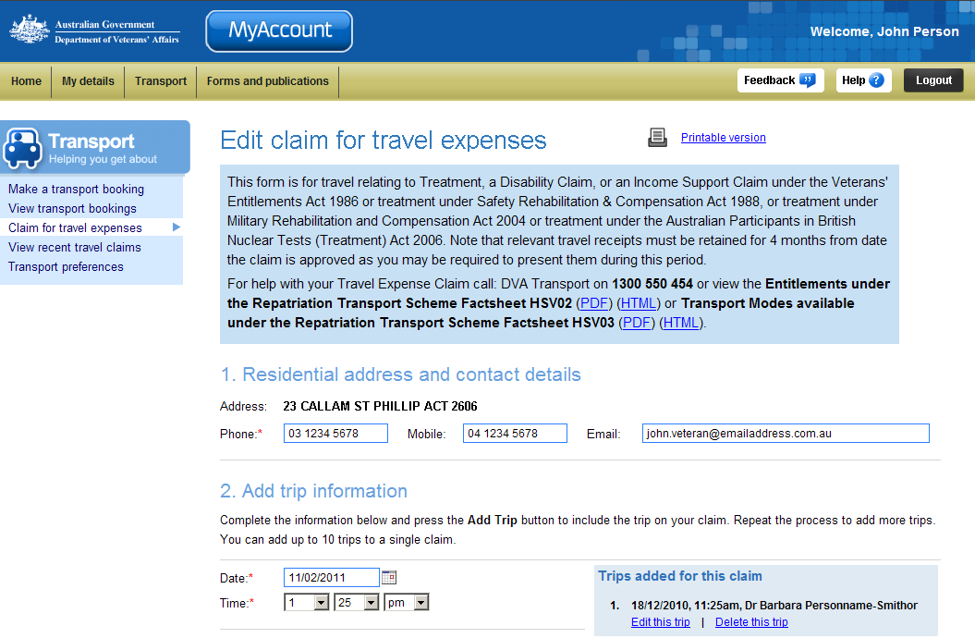
- Make required changes to the claim.
 | For instructions and assistance with the Edit claim for travel expenses page, including adding or deleting trips and submitting the claim, see the Claim for travel expenses help page.

Delete a draft claim
To delete a draft claim:
- Click on the Delete claim link to the right of the draft claim.
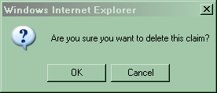
A confirm dialog box displays.
- Click on the OK button.

The View recent travel claims screen updates.
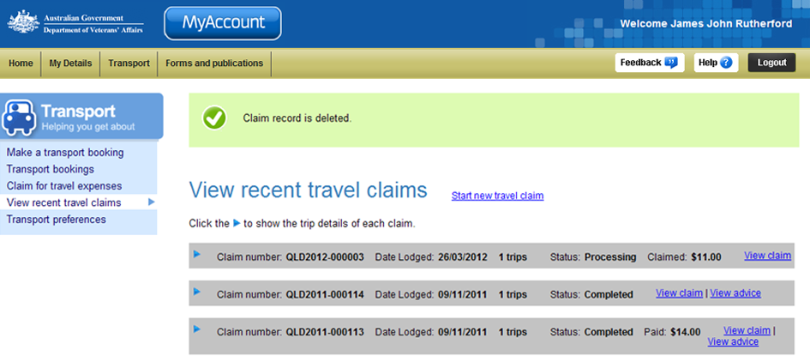
At the top of the screen, a green success message states the draft claim record has been deleted.

Other functions
 | To view another section or perform another transaction related to transport, click on a link in the Transport menu to the left of the page.
 | To get additional help with the View recent travel claims screen, click on the Help button at to the top right of the page.
 | When you are finished using MyAccount, to log out and finish using the service in a secure way, click on the Logout button.

